Egg Roll in a Bowl

Ingredients:
2 tablespoons olive oil
½ cup yellow onions, diced
1 pound lean ground pork OR ground meat of choice
1 teaspoon garlic powder
1 teaspoon ground ginger
1 16-ounce bag coleslaw mix, shredded green cabbage, and carrots
¼ cup lower sodium soy sauce
½ teaspoon black pepper
2 cups white rice OR noodles, cooked (optional)
Green onion, sliced (optional)
Sesame seeds (optional)
Sriracha sauce (optional)

Instructions:
- In a large pot, heat 1 tablespoon of oil over medium heat. Add ground pork. Use a spoon to crumble into pieces. Cook thoroughly until it is no longer pink, about 8-10 minutes.
- Using a strainer or colander, drain the fat from the meat. Set aside.
- In the same pot, add 1 tablespoon of oil. Sauté onions over medium heat until softened, about 3-5 minutes.
- Return the cooked pork to the pot. Add garlic powder and ground ginger. Stir until well combined. Cook for about 1 minute.
- Add coleslaw mix, soy sauce, and black pepper. Stir to combine. Cook for about 5 minutes or until cabbage is wilted and tender. Stir occasionally.
- Serve over cooked rice or noodles.
- Top with green onions, sesame seeds, and sriracha sauce if desired.

Source: LSU AgCenter
Serves: 8
Prep Time: 5 minutes

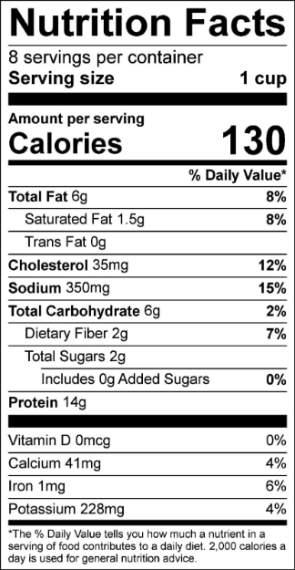
Cook time: 25-30 minutes



Find the video for this recipe and more at LSUAgCenter.com/BuildAHealthyMeal. The Build a Healthy Video Series and recipe cards are made possible through an LSU AgCenter partnership with Louisiana Healthcare Connections. Learn more about Healthy Louisiana Medicaid and Louisiana Healthcare Connections at www.ChooseLouisianaHealth.com

